Practical 7:- Authentication and Middleware Pipeline
Objective: | To implement JWT-based authentication and input validation as part of the Express middleware pipeline.
Problem Statement: | • Add user registration and login functionality to the Task Management application.  • Hash passwords using bcrypt before saving the User document to MongoDB.  • Implement JWT token generation on successful login, with a reasonable expiry (e.g., 1 hour).  • Protect all task routes using an authentication middleware that verifies the JWT.  • Add server-side input validation that rejects malformed requests (e.g., missing title) before they reach the database.
Implementation | Signup Page:-  import { useState } from 'react';  import { Link, useNavigate } from 'react-router-dom';  import { FiMail, FiLock, FiUserPlus } from 'react-icons/fi';  import { useAuth } from '../context/AuthContext.jsx';  import { cn, paperCard, gloss, inputInset, btnPrimary, emboss } from '../styles/classes.js';  import Button from '../components/Button.jsx';  /**  * Register page — centered card with email/password form.  */  const Register = () => {  const navigate = useNavigate();  const { register } = useAuth();  const [email, setEmail] = useState('');  const [password, setPassword] = useState('');  const [confirmPassword, setConfirmPassword] = useState('');  const [error, setError] = useState('');  const [loading, setLoading] = useState(false);  const handleSubmit = async (event) => {  event.preventDefault();  setError('');  if (password !== confirmPassword) {  setError('Passwords do not match');  return;  }  if (password.length < 6) {  setError('Password must be at least 6 characters');  return;  }  setLoading(true);  try {  await register(email, password);  navigate('/');  } catch (err) {  setError(err.response?.data?.message || 'Registration failed');  } finally {  setLoading(false);  }  };  return (  <div className="flex min-h-screen items-center justify-center p-4 bg-background">  <div className={cn(paperCard, gloss, 'w-full max-w-md p-8')}>  <div className="text-center mb-8">  <h1 className={cn(emboss, 'font-display text-2xl font-bold text-graphite-800')}>  Create account  </h1>  <p className="mt-2 text-sm text-graphite-500">  Join TaskFlow and start managing your tasks  </p>  </div>  {error && (  <div  className="mb-6 p-3 rounded-xl bg-red-50 border border-red-200 text-red-700 text-sm"  role="alert"  >  {error}  </div>  )}  <form onSubmit={handleSubmit} className="space-y-5">  <div>  <label htmlFor="email" className="block text-sm font-medium text-graphite-700 mb-1.5">  Email  </label>  <div className="relative">  <FiMail className="absolute left-3 top-1/2 -translate-y-1/2 text-graphite-400" size={18} />  <input  id="email"  type="email"  autoComplete="email"  value={email}  onChange={(e) => setEmail(e.target.value)}  placeholder="you@example.com"  className={cn(inputInset, 'w-full pl-10 pr-4 py-3 text-sm')}  required  disabled={loading}  />  </div>  </div>  <div>  <label htmlFor="password" className="block text-sm font-medium text-graphite-700 mb-1.5">  Password  </label>  <div className="relative">  <FiLock className="absolute left-3 top-1/2 -translate-y-1/2 text-graphite-400" size={18} />  <input  id="password"  type="password"  autoComplete="new-password"  value={password}  onChange={(e) => setPassword(e.target.value)}  placeholder="••••••••"  className={cn(inputInset, 'w-full pl-10 pr-4 py-3 text-sm')}  required  minLength={6}  disabled={loading}  />  </div>  <p className="mt-1 text-xs text-graphite-400">At least 6 characters</p>  </div>  <div>  <label htmlFor="confirmPassword" className="block text-sm font-medium text-graphite-700 mb-1.5">  Confirm password  </label>  <div className="relative">  <FiLock className="absolute left-3 top-1/2 -translate-y-1/2 text-graphite-400" size={18} />  <input  id="confirmPassword"  type="password"  autoComplete="new-password"  value={confirmPassword}  onChange={(e) => setConfirmPassword(e.target.value)}  placeholder="••••••••"  className={cn(inputInset, 'w-full pl-10 pr-4 py-3 text-sm')}  required  disabled={loading}  />  </div>  </div>  <Button  type="submit"  className={cn(btnPrimary, 'w-full py-3')}  size="lg"  disabled={loading}  >  {loading ? 'Creating account...' : (  <>  <FiUserPlus size={18} />  Create account  </>  )}  </Button>  </form>  <p className="mt-6 text-center text-sm text-graphite-500">  Already have an account?{' '}  <Link to="/login" className="font-semibold text-accent-600 hover:underline">  Sign in  </Link>  </p>  </div>  </div>  );  };  export default Register;  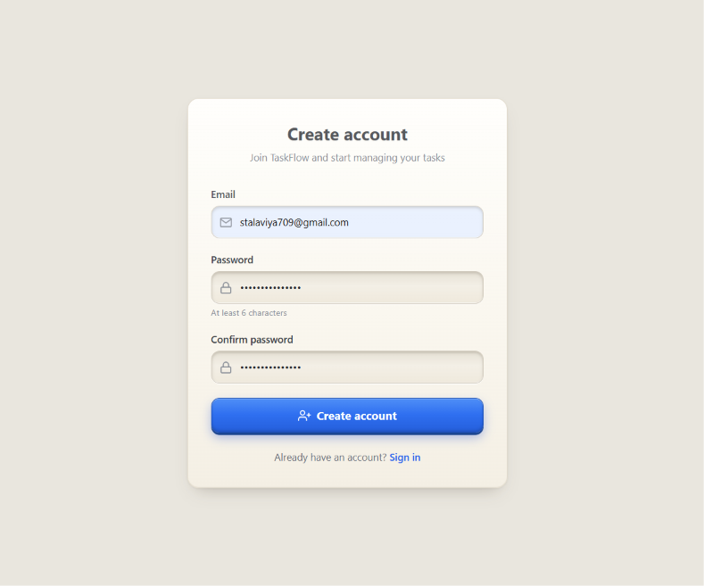  Signin Page:-  import { useState } from 'react';  import { Link, useNavigate } from 'react-router-dom';  import { FiMail, FiLock, FiLogIn } from 'react-icons/fi';  import { useAuth } from '../context/AuthContext.jsx';  import { cn, paperCard, gloss, inputInset, btnPrimary, emboss } from '../styles/classes.js';  import Button from '../components/Button.jsx';  /**  * Login page — centered card with email/password form.  */  const Login = () => {  const navigate = useNavigate();  const { login } = useAuth();  const [email, setEmail] = useState('');  const [password, setPassword] = useState('');  const [error, setError] = useState('');  const [loading, setLoading] = useState(false);  const handleSubmit = async (event) => {  event.preventDefault();  setError('');  setLoading(true);  try {  await login(email, password);  navigate('/');  } catch (err) {  setError(err.response?.data?.message || 'Invalid credentials');  } finally {  setLoading(false);  }  };  return (  <div className="flex min-h-screen items-center justify-center p-4 bg-background">  <div className={cn(paperCard, gloss, 'w-full max-w-md p-8')}>  <div className="text-center mb-8">  <h1 className={cn(emboss, 'font-display text-2xl font-bold text-graphite-800')}>  Welcome back  </h1>  <p className="mt-2 text-sm text-graphite-500">  Sign in to your TaskFlow account  </p>  </div>  {error && (  <div  className="mb-6 p-3 rounded-xl bg-red-50 border border-red-200 text-red-700 text-sm"  role="alert"  >  {error}  </div>  )}  <form onSubmit={handleSubmit} className="space-y-5">  <div>  <label htmlFor="email" className="block text-sm font-medium text-graphite-700 mb-1.5">  Email  </label>  <div className="relative">  <FiMail className="absolute left-3 top-1/2 -translate-y-1/2 text-graphite-400" size={18} />  <input  id="email"  type="email"  autoComplete="email"  value={email}  onChange={(e) => setEmail(e.target.value)}  placeholder="you@example.com"  className={cn(inputInset, 'w-full pl-10 pr-4 py-3 text-sm')}  required  disabled={loading}  />  </div>  </div>  <div>  <label htmlFor="password" className="block text-sm font-medium text-graphite-700 mb-1.5">  Password  </label>  <div className="relative">  <FiLock className="absolute left-3 top-1/2 -translate-y-1/2 text-graphite-400" size={18} />  <input  id="password"  type="password"  autoComplete="current-password"  value={password}  onChange={(e) => setPassword(e.target.value)}  placeholder="••••••••"  className={cn(inputInset, 'w-full pl-10 pr-4 py-3 text-sm')}  required  disabled={loading}  />  </div>  </div>  <Button  type="submit"  className={cn(btnPrimary, 'w-full py-3')}  size="lg"  disabled={loading}  >  {loading ? 'Signing in...' : (  <>  <FiLogIn size={18} />  Sign in  </>  )}  </Button>  </form>  <p className="mt-6 text-center text-sm text-graphite-500">  Don't have an account?{' '}  <Link to="/register" className="font-semibold text-accent-600 hover:underline">  Create one  </Link>  </p>  </div>  </div>  );  };  export default Login;  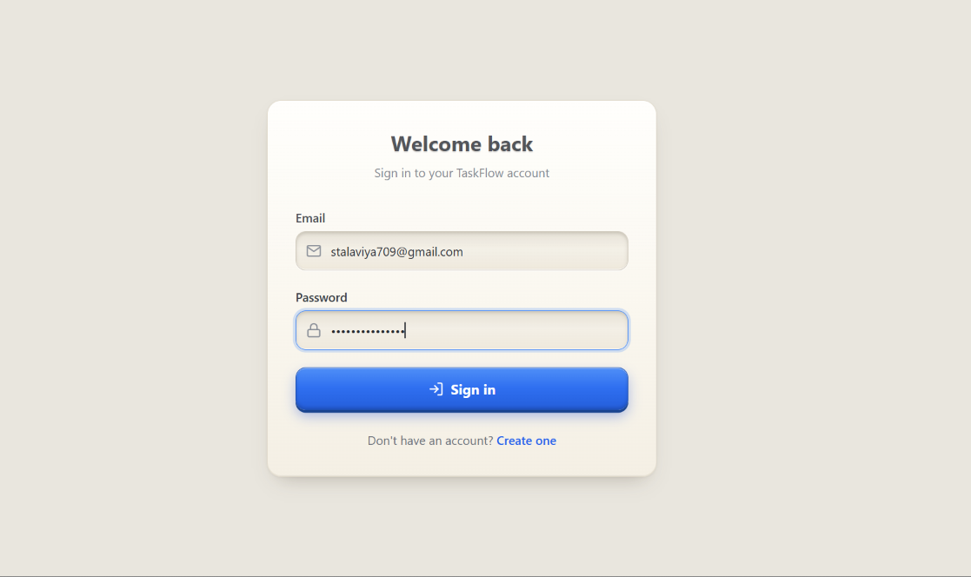  Database:-  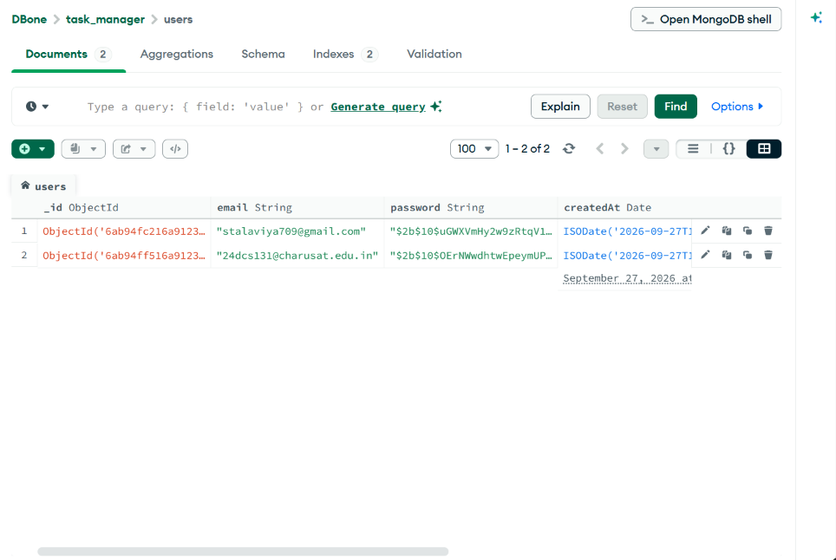
Outcome | Students will be able to implement a complete authentication flow using JWT, protect backend routes with middleware, and enforce server-side input validation.

